***“FOODIE”***

***A FOOD HOME DELIVERY***

***WEB APPLICATION***

***When you eat food with your family, it always tastes better!!***

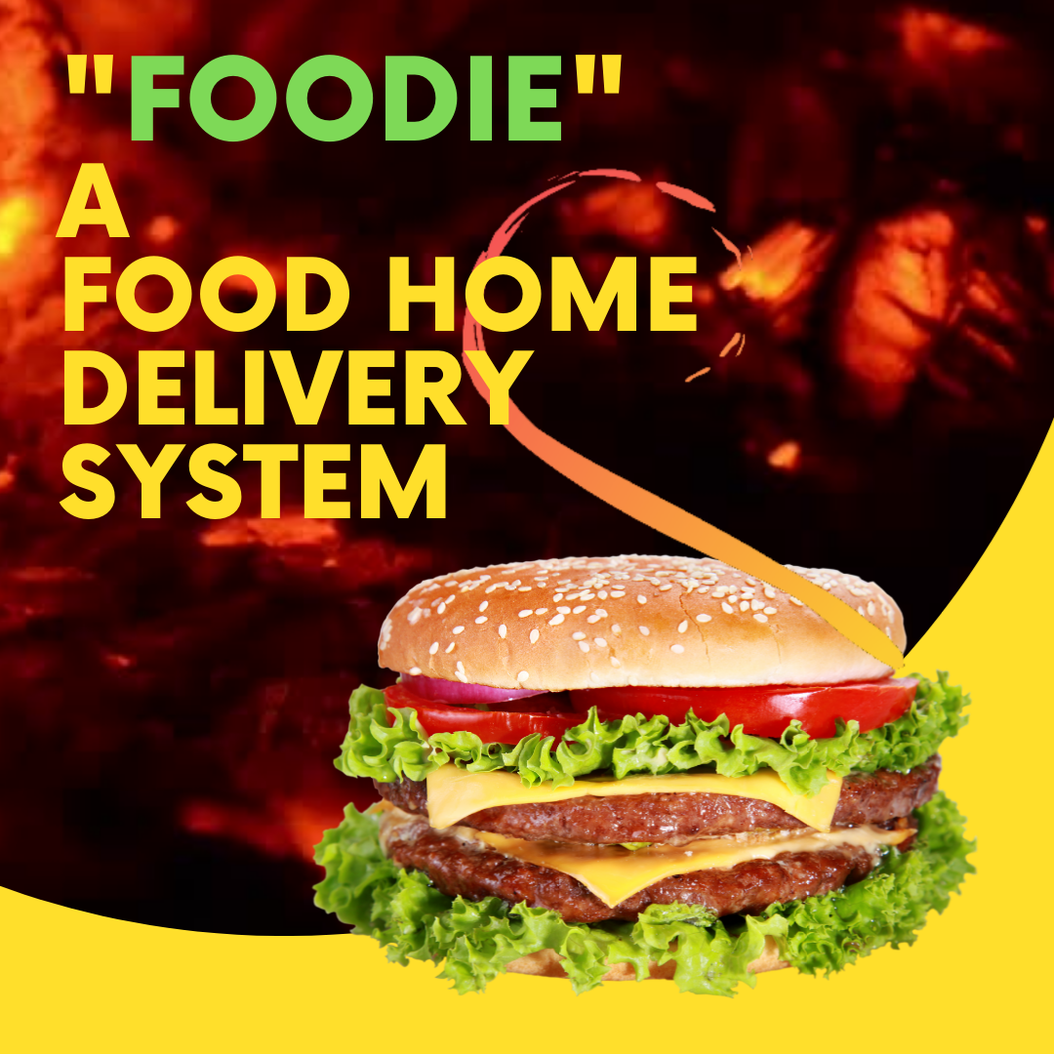

***INTRODUCTION***

“**Foodie**”, **A Food Home Delivery Web App**, is a restaurant specific Home delivery system. It is aimed to cater a restaurant’s, food court’s personal home delivery needs.

We are in the era, were apps like Zomato, Swiggy, Uber Eats etc are dominating the market. However, Brands like Dominos, McDonalds, Pizza hut, Burger King etc have a personal system which provide them brand value, independency etc which is still a dream and a matter of pride for many.

Foodie full fills this need, it connects a local food store to the customers. A user can register and add the items to the cart, proceed with the payments and enjoy favourite food at home with friends and family.



***WHAT ARE WE TRYING TO BUILD?***

We are trying to build a platform which is a **restaurant specific Food Home delivery Application**. It is aimed to cater a restaurant’s / food court’s personal home delivery needs.

It will be a place where a restaurant or food court can row its business by being independent, building its brand and working on its own terms and catering to the needs of people visiting store remotely.

The users also get benefited from this service as they don’t have to wait at stores long for the order, and they get it delivered at home.

As of now, the app will have:

* **A dashboard Showing what a restaurant have in kitchen as Menu Items.**
* **A Signup / Login Page,**
* **A dashboard Showing what a restaurant have in kitchen.**
* **Ability to add items to a cart without logging in.**
* **Ability to place the order by entering the address and phone number after successful login is done.**
* **Ability to register , if not already done.**
* **Adding incorrect details or leaving the textbox empty prompts a set of pre-assigned errors.**
* **Option to track your order and see order history of a customer.**
* **Separate login Id for Customers and Admin.**
* **A Customer user profile to view all orders under his name.**
* **Admin has the ability to view all the orders placed, change its status.**
* **Ability to show the real-time status of your order placed/confirmed/in route/ delivered etc, controlled from a separate admin page.**
* **Admins can check for placed order and update its status.**

*\*\*\*\*\* happy customer, happy life \*\*\*\*\*\**

***PURPOSE***

The purpose of this project is to describe the a restaurant specific food order and delivery system, It is aimed to cater a restaurant’s / food court’s personal home delivery needs.

The users also get benefited from this service as they don’t have to wait at stores, long for the order, and they get it delivered at home.

Idea is to make a restaurant independent in terms of its working and terms,

Helps a restaurant not to get left behind in this era of digitalisation.

It empowers the restaurant owner(entrepreneur) to carry out his business with ease.

***TECHNOLOGIES***

***USED***

In building this Foodie web app, we will majorly use:

* Node.js – A JavaScript runtime.
* Express js framework.
* Template Engine – ES6.
* Mongo dB Atlas, a cloud based No-SQL database, for database handling.
* Bcrypt.js: library to help you hash passwords.
* Passport: It is authentication middleware for Node.js .
* Socket.io: enables real-time bidirectional event-based communication.
* Noty: It is a notification library that makes it easy to create alert - success - error - warning - information - confirmation
* Moment.js: it is used for formatting Date and time.



***UPDATES THAT MIGHT COME IN FUTURE***

* A Google / Facebook Login.
* A Payment Gateway.
* An improved Customer profiles.
* Live Tacking through google maps.
* Overall UI improvements
* Mobile notifications for the order status

And much more.



***WORKING TOGETHER***

* ANJALI
* ANUJ TIWARI

BATCH: CVRAMAN

*** THANK YOU***